Structured Submission Template for Validation and XML JATS Conversion (SciELO PS) by WTsolutions.pt
Use this template to prepare the manuscript for automatic analysis and conversion. Section names must not be changed, as they are used for technical identification during processing (they will not be retained in the final published version). Use paragraphs (¶ / Enter), not line breaks, to separate sections. Place images inline within the text (not floating, in front of text, or with text wrapping).
The accepted article types are: Research article; Review article; Case report; Brief report; Editorial; Letter; and Correction.
Journal ID
Example Journal ID
Journal Title
Example Journal Full Title
Journal Abbreviated Title
Example
ISSN
0000-0000
Publisher
Example publisher
Article DOI
10.1234/12345
Publisher Article ID
123
Article Type
Research-article
Article Category
Original Article
Article language
English
Article Title
Example Title
Article Subtitle
Example Subtitle
Authors
Example Name¹ (ORCID: 0000-0000-0000-0000)
Affiliations
1- Example Institution, Example Unit/department, Example City, Portugal
Corresponding Author
Example Name, email@email.com
Abstract
Example abstract. Background: This section briefly introduces the research context and the specific problem addressed. Objective: State the main objective or research hypothesis. Methods: Describe the methodology used. Results: Summarize the most relevant findings. Conclusion: Explain the implications of the results and their contribution to the field.
Keywords
keyword1; keyword2; keyword3; keyword4
1. Introduction
This section introduces the research context and situates the article within a broader field of study. It should begin by presenting the general topic and gradually move toward the specific issue, problem, or gap that the article addresses. The introduction is expected to clarify the relevance of the topic, both academically and in practical or societal terms, and to define the main objectives of the work. In this process, authors are encouraged to engage with key references that frame the discussion and demonstrate awareness of existing literature. A clear and well-structured introduction typically follows a progression from general context to specific focus, as discussed by Swales and Feak (2012), who emphasize the importance of establishing a research territory, identifying a gap, and occupying that gap. Similarly, Booth, Colomb, and Williams (2016) highlight the role of the introduction in defining a problem that justifies the research. This section should remain focused and avoid detailed methodological explanations or the presentation of results, which belong in later sections.
Table 1: Example Table
Example | Example | Example | Example | Example
Example | Example | Example | Example | Example
Example | Example | Example | Example | Example
Example | Example | Example | Example | Example

Figure 1. Title or description of the figure2.
Source: Author Fig1 (2026).
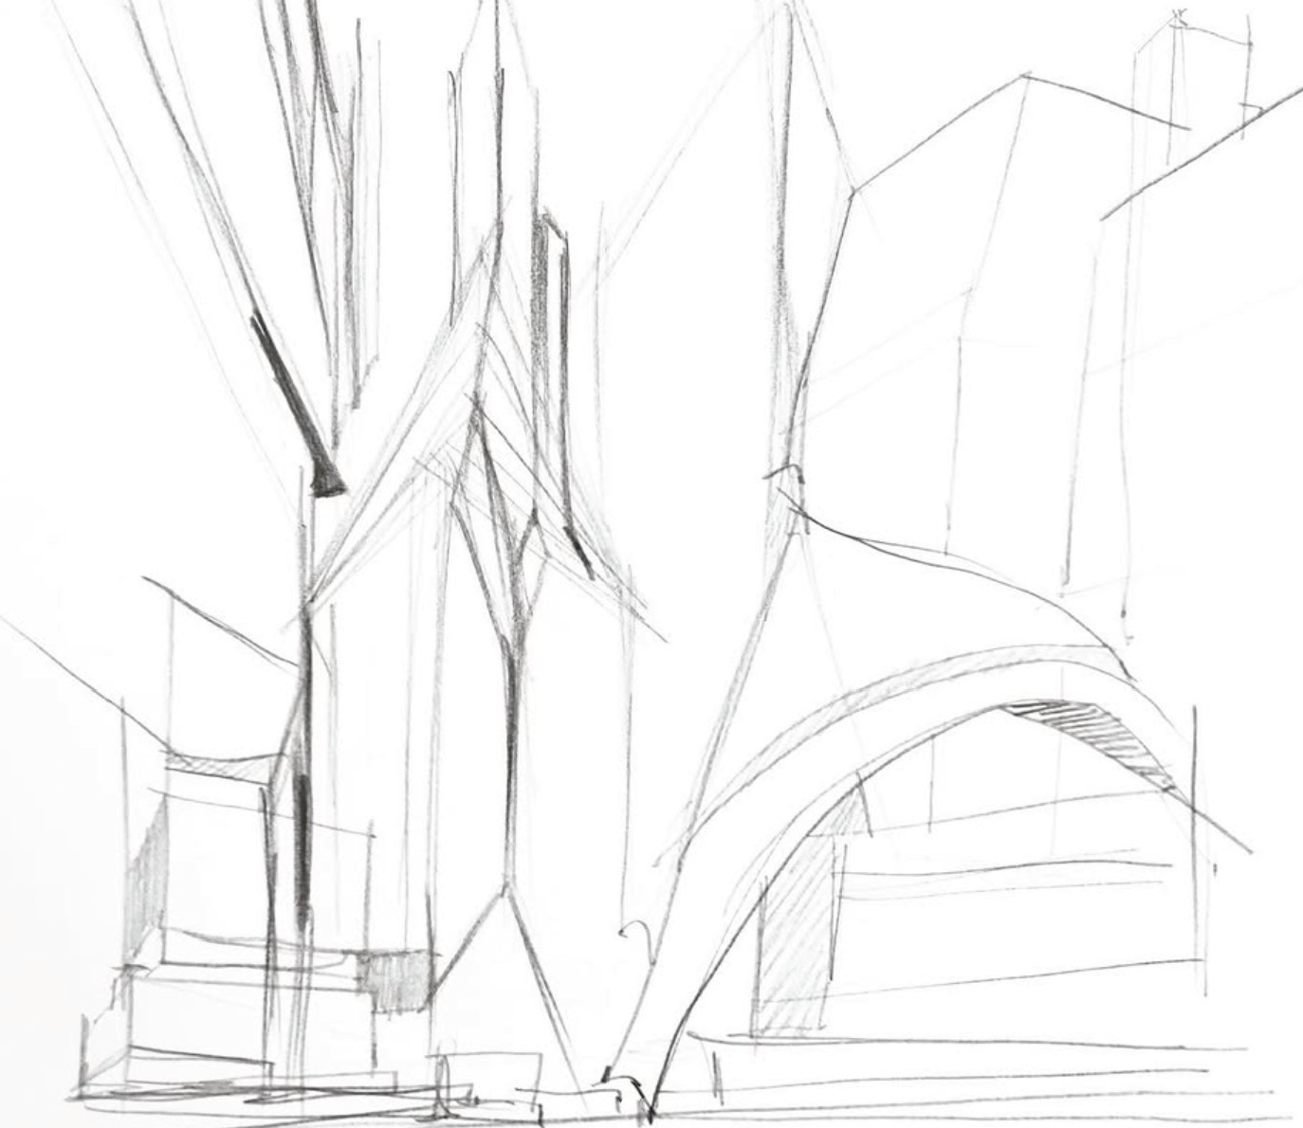
Figure 2. Title or description of the figure 2.
Source: Author Fig2 (2026).
2. Conceptual Framework / Methodology / Approach
This section explains how the research was developed and provides the foundation for understanding how conclusions are reached. Depending on the nature of the article, it may present a theoretical or conceptual framework, describe the methodological approach, or outline the processes and strategies used in the work. In more traditional academic research, this typically includes the research design, methods of data collection, and analytical procedures, following established approaches such as those described by Creswell (2014). In case-based or qualitative studies, the section may focus on contextual depth and interpretative strategies, as discussed by Yin (2018). For practice-based or artistic research, the emphasis may shift toward the creative process, materials, spatial or visual strategies, and modes of production. Regardless of format, the section should clearly articulate how the work was conducted and ensure coherence with the objectives defined in the introduction. The level of detail should be sufficient to allow the reader to understand the logic and validity of the approach.
3. Conclusion
The results obtained suggest that our initial optimization hypothesis was correct. Contrary to the framework proposed by Johnson et al. (2026), which advocated for a centralized structure, our data indicates that decentralization improves system resilience. This finding aligns with the theory of "Computational Elasticity" introduced by Chen (2026), where load distribution is viewed as the determining factor for long-term hardware sustainability. Nevertheless, it is necessary to consider the thermal limitations discussed by Oliveira (2026) when replicating these tests under extreme conditions.
References
Chen, L. (2026). The Foundations of Computational Elasticity. Journal of Future Tech, 12(3), 45-60.
Johnson, P., et al. (2026). Centralized Architectures in the Modern Age. International Systems Review, 8(1), 102-115.
Müller, H. (2026). Data Integrity in Simulated Environments. European Computing Quarterly, 22(4), 18-30.
Oliveira, A. (2026). Thermal Limits of Next-Gen Processors. Advanced Engineering Letters, 5(2), 201-210.
Silva, R., & Santos, M. (2026). Neural Integration and Latency Optimization. Journal of AI Research & Development, 15(6), 77-89.

